Design a simple cash register similar to one found at McDonald’s or Burger King. To do this,  
determine a menu of five or six items from the restaurant. Also, include a Total button or a clear  
button or possibly both. Also, include a means for backing out of a mistake without starting over  
from zero. Display the cost of the total order in the PLC at an address in the data table. Use  
floating point math and you are encouraged to do so.  
For example:

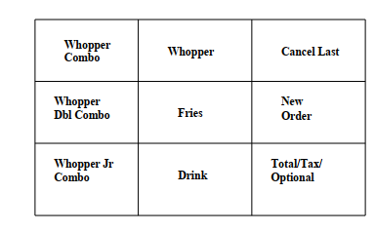

Find the approximate prices from a McDonald’s or Burger King for the items chosen. When an  
item is entered, its count is incremented automatically by one. If a button is entered multiple  
times, the count is incremented to display the total count. If a mistake is made, the attendant  
must be able to back up at least one entry and erase the last item or decrement that item by one.

Hints to the base lab:

Notice that counters may be referenced as either Count Up or Count Down. If the count is  
counting up, the count is incremented in rung 0000. If the count is counted down, the count is  
decremented in rung 0001. Individual inputs are used to increment each product choice.  
However, to decrement the count, a separate button labeled “Cancel Last” is used. This button  
must remember the last product chosen and decrement that item. Use the logic in chapter 7  
“Relay Instructions” to remember when a button was pushed.  
Use the Count Up/Count Down logic for holding active counts for the various items in the cash  
register.  
Make the following changes for the application:  
1. Display the total price for the order on the screen. Use Floating Point numbers where  
possible. Display totals in $xx.xx format.

2. Add a second screen to allow the manager to change base prices for each item. Do not  
include a password to move from screen to screen.  
3. Include a button to add 6.25% tax if not “To Go” for the order.  
4. Include a ‘live’ count of the number of each item ordered.  
5. Create means for going from Screen 1 to Screen 2.  
6. Screens should resemble the following for Lab.1:

